ACTIVE FILTER

Aim
To design and set up the active First order filters using Op-amp.

Apparatus Required
Op-amp, resistors, capacitors, breadboard, CRO, function generator and power supplies.

Design:

$$\text{Fc}\text{=}\frac{\text{1}}{\text{2}\text{Π}\text{RC}}$$

Circuit Diagram

First Order LPF
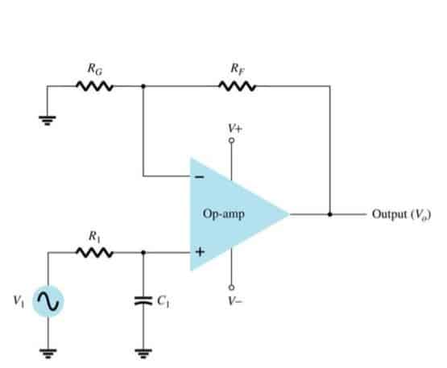

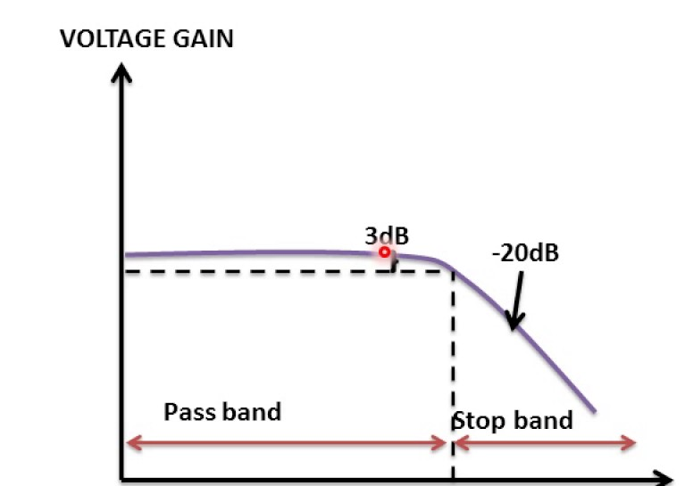

First Order HPF
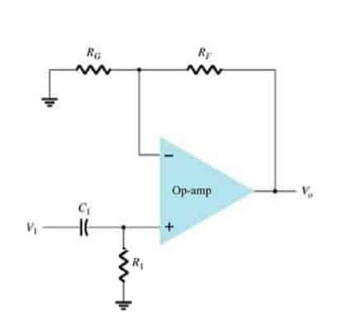

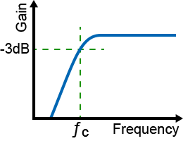

Procedure
- Assemble the first-order active filter circuit on the breadboard.
- Connect IC 741 to a ±15 V DC supply.
- Connect the function generator to the input of the filter.
- Apply a sinusoidal input, for example, 1 V Vm
- Initially set the input frequency well below the calculated cut-off frequency.
- Observe Vin and Vout on the CRO/DSO.
- Measure the output voltage at different input frequencies.
- Calculate the voltage gain IN Decibel.
- Increase the frequency gradually through and beyond the expected cut-off frequency.
- Record the output voltage at each frequency.
- Identify the frequency at which the gain becomes approximately −3 dB from the passband gain.
- Plot the frequency-response curve of gain (dB) versus frequency.
- Compare the experimentally obtained cut-off frequency with the theoretical value.

Observation Table
S. No. | Frequency (Hz) | Vin (V) | Vout(V) | Gain | Gain (dB)
1 | 30Hz | 1V | 1V | 1 | 0
2 | 50Hz | 1V | 1V | 1 | 0
3 | 80Hz | 1V | 1V | 1 | 0
4 | 100Hz | 1V | 1V | 1 | 0
5 | 150Hz | 1V | 1V | 1 | 0
6 | 500Hz | 1V | 500mV | 500 | -6.62
7 | 1kHz | 1V | 400mV | 400 | -7.9
8 | 2kHz | 1V | 200mV | 200 | -13.9
9 | 3Hz | 1V | 100mV | 100 | -20

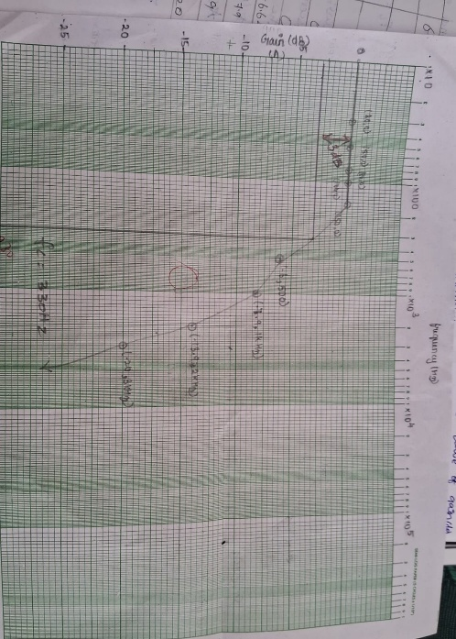

Result:
Thus Designed the First order filters using op amp and obtained the results as Cutoff frequency of low pass filter is 320Hz .

